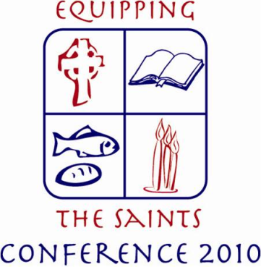
Establishing a Spirit of Mission Through a Healthy Parish Council
Linking Parish Ministries and Parish Council
_________________________________________________________________________________
What is Consensus
Consensus occurs when the Parish Council agrees upon a decision, strategy, or plan of action that all council members can live with, and can support for the good of the church
Consensus is often incorrectly assumed to imply complete agreement, but is rather the ability to support a given decision.
Useful Phrases for Discerning Consensus:
Does everyone accept this decision?
Is anyone opposed to this decision?
Can everyone live with this decision?
Can everyone support this decision?
Benefits of Making Decisions by Consensus:
- Greater sense of parish unity
- Improved morale and parish culture
- Increased productivity and quality of work
- Consensus has many benefits over a ‘for/against’ vote – especially when considering emotionally charged issues
- Consensus forces us to see one another’s point of view and to bridge our differences.
- Wherever God’s work is being done, we must be vigilant to avoid divisions
- Reduced cost in terms of time and resources

Ann Marie Gidus- Mecera / amecera@columbus.rr.com / ameceracommunications.webs.com
In case of deadlock…
If a member or small group of members is not sincerely working toward consensus, but is rather trying to block the decision-making process, it is reasonable to move forward with the consensus of the other members.
Dissenting individual’s needs must be actively addressed after the meeting in order to keep this lack of agreement from causing divisions in the parish council and in the parish at large.
- A group process of seeking substantial though not necessarily unanimous agreement on a significant matter. The group strives to attain a conclusion which all can support, even if some still disagree.
- Consensus can be described in the following way:
"I understand what most of you would like to do. I personally would not do that, but I feel that you understand what my alternative would be. I have had sufficient opportunity to openly share my thoughts and feelings. I feel that I have been listened to, but I clearly have not been able to sway you to my point of view. Therefore, I will support what most of you wish to do."

Voting May be Necessary…
- When a specific action requires a vote, such as approval of a contract or sale of property
- When time does not allow for consensus and a decision must reached. Advance planning usually manages to avoid this situation by addressing the issue well in advance of the deadline

